

**UNIVERSITY OF PETROLEUM & ENERGY STUDIES**

**College of Engineering Studies Dehradun**

**LAB FILE**

**Experiment 2**

Programme : B. Tech in Computer Science and Engineering with Specialization in DevOps

Course : Continuous Integration & Continuous Deployment Lab

No. of credits : 1

Semester : V

Session : July-December 2020

Batch : 2018-2022

Faculty : Dr. Hitesh Kumar Sharma

Submitted By:

Ingit Singhal

Sap id: 50056426

Roll No : R171218048

**Lab Experiment 2**

**Jenkins Integration with GitHub.**

GitHub is a major Source Code Management tool that is widely used in the industry. Its integration with Jenkins is the first step towards building a successful CI/CD pipeline.

To integrate Jenkins with GitHub, follow the following steps:

1. Open your Jenkins and move to the manage Jenkins section.

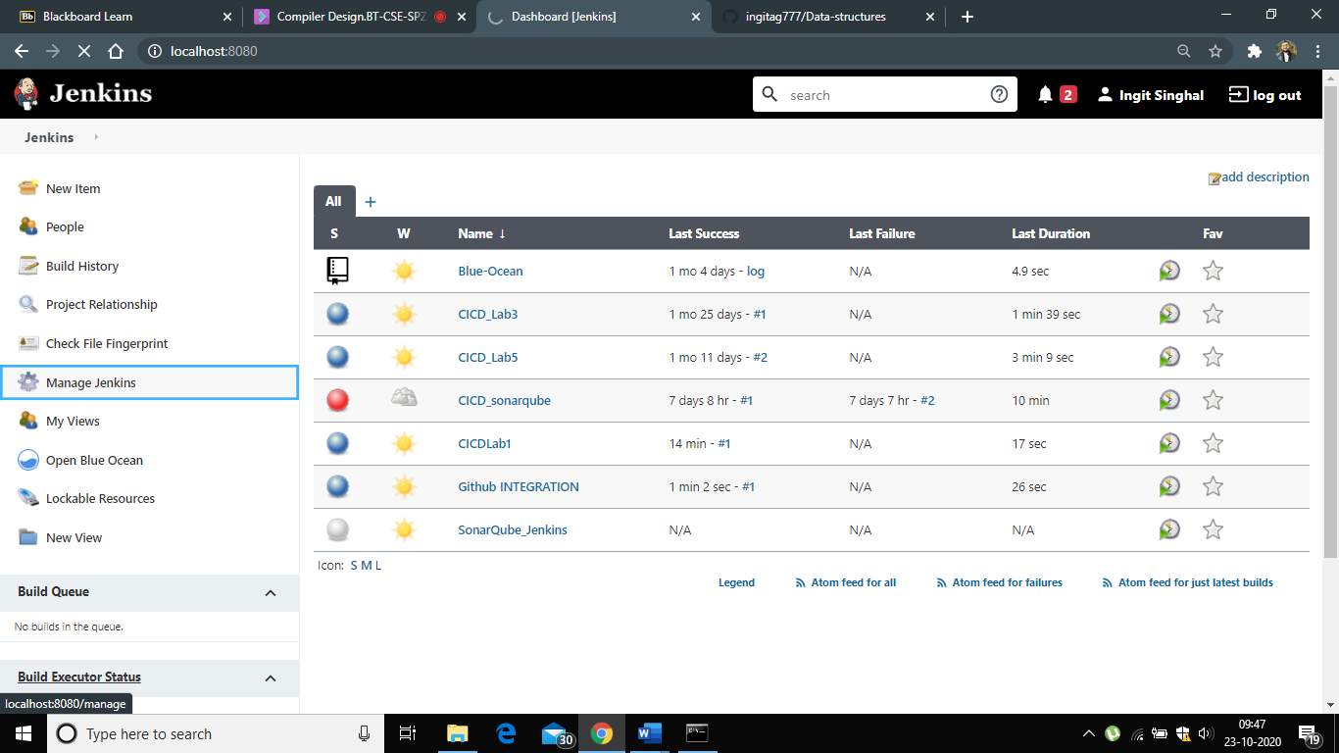

2. Now move on to the global tool configuration section

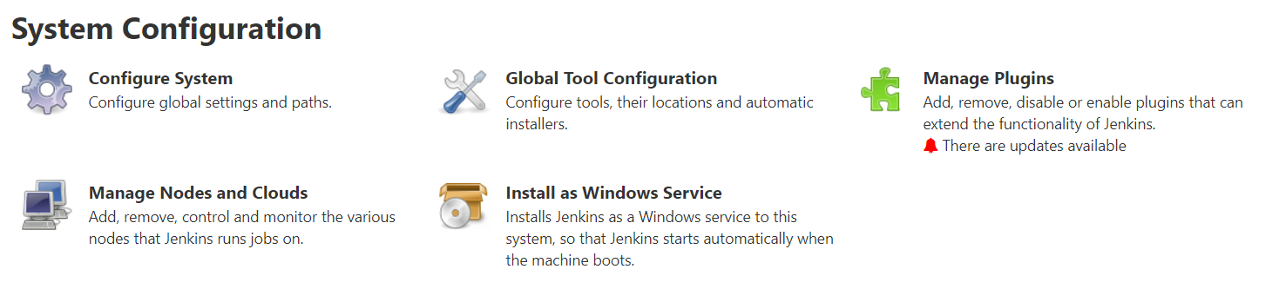

3. The next step is verifying that the correct path to the git executable is given in git installations.

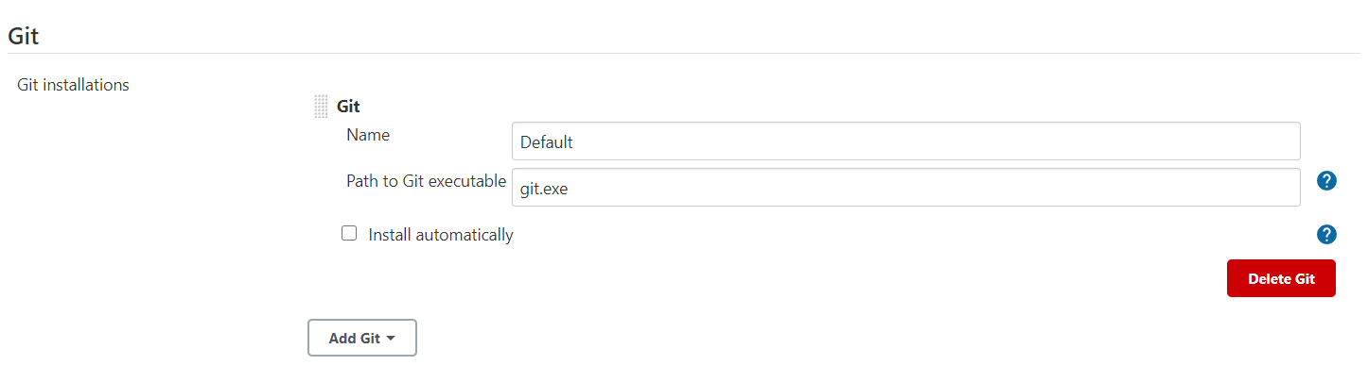

4. Now we are ready to integrate GitHub repository to our project. Let us create a new freestyle project in the Jenkins.

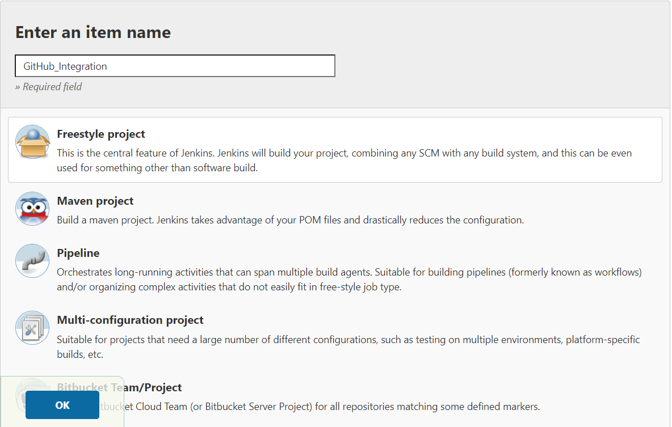

5. Now all we have to do is to configure our project to integrate with GitHub. For this, do the following steps:

a. Go to the Source Code Management part in the configuration for the project and select Git there.

b. Then you will be asked to provide the URL of the GitHub repository that needs to be integrated. Provide the URL.

c. If the repository is private then add the GitHub credentials. For public repositories you can skip the credentials part.

d. Now, the repository will be integrated with Jenkins. Save the changes.

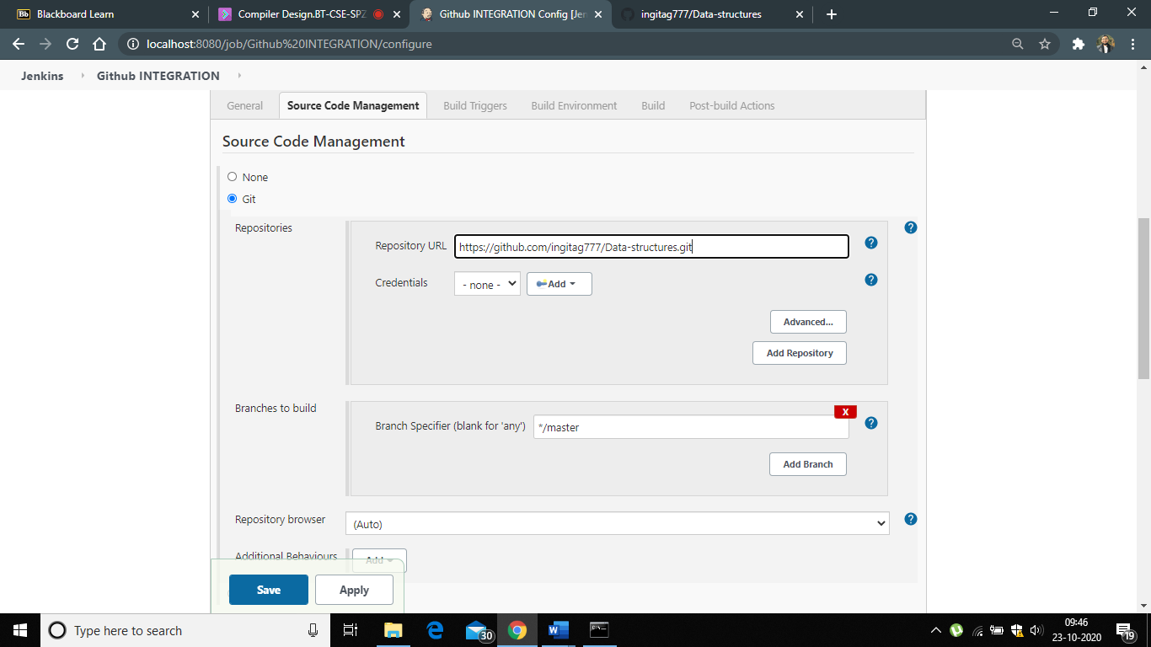

6. Now build the project.

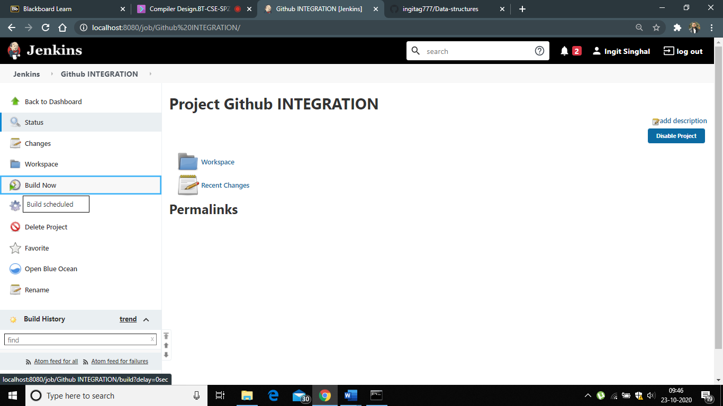

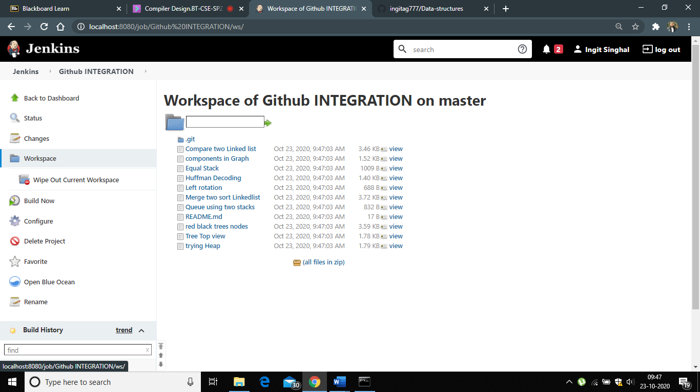

7. After successful build, go to the Workspace folder of the project. The contents of your GitHub repository will be available there. This verifies the integration of Jenkins and GitHub.